Pre-registration: Colour phi report task

Motivation
This experiment aims to replicate the colour phi illusion. This illusion is a form of postdiction effect and has been used to support theories of consciousness. However, there has been little evidence on the replicability and robustness of this illusion. We aim to examine the colour phi illusion in a format that allows participants to report not seeing any motion.

Methods

Participants
400 participants will be recruited from Prolific.com, filtered for intact corrected vision, no colourblindness, English as first language, and a prolific study approval rate above 95%. The experiment lasts around 5 minutes, and participants will be paid 80p, approximately equivalent to £9.6/hour.

Procedure

Stimuli details
Two types of animated stimuli are used. The illusion stimuli are designed to closely mirror those used in the original experiment (Kolers & von Grunau, 1975). They contain two flashes of different colours, separated by a distance and time interval. The specific parameters used are identical to the original experiment: the flashes are either two squares with side lengths measuring 0.9 visual angles, or two equilateral triangles of the same area, separated by 3.6 visual angles between their midpoints, each appearing for a duration of 150 ms. In the illusion condition, the screen will appear empty for 50 ms between the two stimuli, as was the case in Kolers & von Grunau. In the baseline condition, this will be increased to 500 ms, a value chosen arbitrarily to give rise to minimal motion perception.
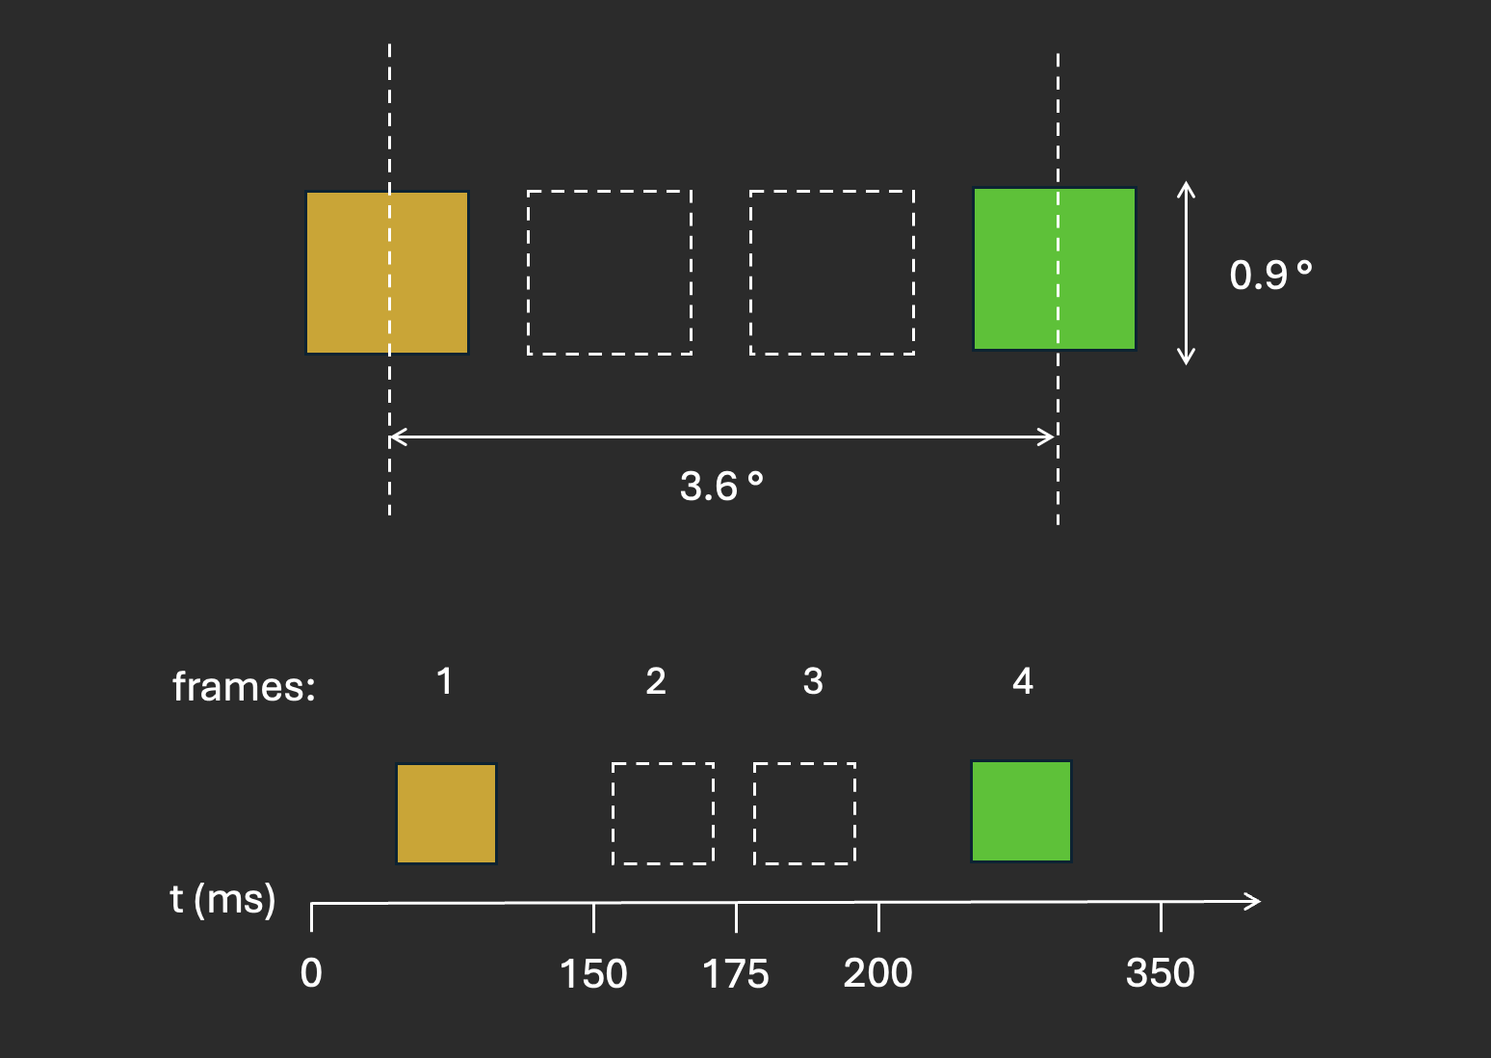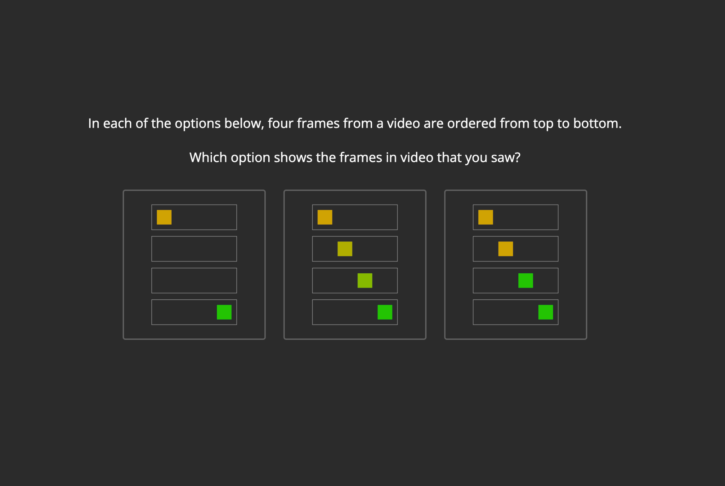
Figure 1: Stimulus parameters Figure 2: Frame sequences

Experiment design
First, participants complete a screen size and visual angle estimation using JsPsych’s plugin “virtual chinrest”. This involves two phases: in phase one the pixel to cm conversion is measured by resizing an image to match the size of a credit card; in phase two the viewing distance is measured with a blind spot task.
Then, participants are told that they will be shown a video and asked to pay close attention:
“In this experiment, we will show you a video on the screen for a brief moment. You will need to pay close attention: the entire video will last less than a second! You will then be asked to describe what you saw in detail.”
To help participants focus, a reference region is displayed on the screen at the location where stimuli will be played:
“The grey rectangle indicates the area where the video will be displayed. Once you press “continue”, the video will start.” After one second, one of the four stimuli (illusion, discrete, continuous, or baseline) is presented.
Participants will then be given an open text box to report what they saw. They will only be able to submit their response once they write at least 20 words. We will then ask, “How many shapes were in the video?”, allowing participants to respond with any number. Finally, we ask, “Please choose, between the following options, which is the video that you saw.” Here, the options are illustrations of frame sequences in each of three possible stimulus conditions (illusion, discrete, and continuous). An example is shown in Figure 2.

Randomization
This study involves a between subject design with one factor, stimuli type (illusion stimuli, baseline stimuli). The colour (red - blue, yellow -green) and shape (square, triangle) of flashes in the animated stimuli are also randomized.
Data analysis

Rejection criteria
Participants will be rejected if they report not having seen the stimulus at all or if their report of what they saw does not feature geometric shapes. Participants will also be excluded if the experiment records frames not being displayed on their monitor.

Hypotheses and analysis plan
Six different hypotheses will be tested, all concerning a difference between proportions in the two conditions. They will all be tested with independent-samples Z-tests. We will use the standard p<.05 criterion for significance.
H1 [motion reports]:
From the verbal reports, we will extract whether the participants refer to a movement. We test the null hypothesis that, in the illusion stimuli condition, the proportion of participants reporting motion will not be significantly different from the proportion in the baseline stimuli condition.

H2 [colour change reports]:
From the verbal reports, we will extract whether the participants refer to any colour change. We test the null hypothesis that, in the illusion stimuli condition, the proportion of participants reporting any colour change will not be significantly different from the proportion in the baseline stimuli condition.

H3 [discrete colour change reports]:
From the verbal reports, among the participants who refer to any colour change, we then extract whether the colour change referred to is discrete, continuous, or not specified. We test the null hypothesis that, in the illusion stimuli condition, the proportion of participants reporting discrete color change will not be significantly different from the proportion in the baseline stimuli condition.

H4 [shape number perception]:
From the reports of the number of shapes seen, among the participants who report seeing either one or two shapes, we extract the proportion of participants reporting seeing one shape. We test the null hypothesis that the proportion of participants seeing one shape will not be significantly different between the illusion stimuli condition and the baseline stimuli condition.

H5 [frame sequence type]:
We test the null hypothesis that the proportion of participants choosing a frame sequence with in-between frames will not be significantly different between the illusion stimuli condition and the baseline stimuli condition.

H6 [frame sequence colour change]:
Among the participants choosing a frame sequence with in-between frames, we extract the proportion of participants choosing a frame sequence with discrete colour change. We test the null hypothesis that the proportion choosing discrete colour change will not be significantly different between the illusion stimuli condition and the baseline stimuli condition.

Sample size justification
We use a sample size of 400 participants (200 participants in each condition). The difference between two groups that can be detected depends on proportion in the baseline condition, assuming 5% of participants report motion in the baseline condition, we will have a statistical power of 95% to detect an effect size corresponding to an illusion condition proportion of 16%.

References:
Kolers, & von Grunau. (1975). SHAPE AND COLOR IN APPARENT MOTION’.

